Notes on Using Jeff’s simulator

Once complete....the start up process
$ roslaunch ackermann_vehicle_gazebo ack_new.launch
$ roslaunch nav joyop.launch # if you want to drive using the joystick
$ roslaunch nav nav_newteb.launch
$ rviz -d ~/catkin_ws_sim/src/nav/ack_new.rviz
If you want to see the functions, $ rosrun rqt_graph rqt_graph

- Build a clean Ubuntu 20 laptop and install ROS using “ros_desktop_full install” (link)
- Go to https://drive.google.com/drive/folders/1Lsu2ZN3aeGRUzJJqlfFOejG5v3KxXSHT
- Download catkin_ws_sim_phase2, extract and move to home directory
- Original note: Go into the resulting directory and copy the catkin_ws_sim_phase2 directory to your home directory. This will be in addition (i.e. Alongside of) your existing catkin_ws.
- 11/12/22 - I’m going to copy these folders into my catkin_ws so I don’t have 2.
- 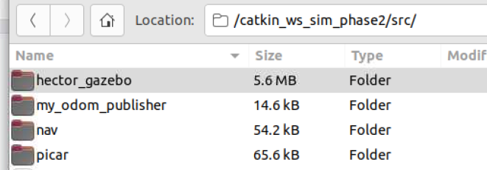
- This is a list of dependencies to load. Load all of these before you do a catkin_make.
  - $ sudo apt-get install ros-noetic-ackermann-msgs
  - $ sudo apt-get install ros-noetic-gazebo-ros-pkgs # already newest
  - $ sudo apt-get install ros-noetic-gazebo-ros-control # already newest
  - $ sudo apt-get install ros-noetic-effort-controllers
  - $ sudo apt-get install ros-noetic-geographic-msgs
  - $ sudo apt install ros-noetic-joy
  - $ sudo apt install ros-noetic-teleop-twist-joy
  - $ sudo apt-get install ros-noetic-move-base-flex
  - $ sudo apt-get install ros-noetic-teb-local-planner
  - $ sudo apt install ros-noetic-tf2-tools
  - $ sudo apt-get install ros-noetic-navigation

  - Original: Open a window; $ cd catkin_ws_sim_phase2; $ catkin_make
  - 11/12/22: Open a window; $ roscd; $ cd ..; $ catkin_make

- Add catkin_ws_sim_phase2 to bashrc $ nano ~/.bashrc
  - Add >source ~/catkin_ws_sim_phase2/devel/setup.bash
  - Comment out other source statements. For example:
    - ># source /opt/ros/noetic/setup.bash
    - ># source /home/al/catkin_ws/devel/setup.bash

- Once completed, fix the execute permissions on the Python files.
- Original: $ cd /home/al/catkin_ws_sim_phase2/
- 11/12/22: $ cd /home/tractor/catkin_ws/src/my_odom_publisher/src
- $ chmod +x odom.py
- $ cd /home/al/catkin_ws_sim_phase2/src/my_odom_publisher/src/
  - $ chmod +x odom.py
- $ cd /home/al/catkin_ws_sim_phase2/src/nav/nodes
- 11/12/22 - $ cd /home/tractor/catkin_ws/src/nav/nodes
  - $ chmod +x cmd_vel_to_ackermann_drive.py
  - $ chmod +x joyop.py
  - $ chmod +x mod_cmd_vel_to_ackermann.py
- $ cd /home/al/catkin_ws_sim_phase2/src/picar/src/ackermann_vehicle_gazebo/scripts
- 11/12/22 - $ cd /home/tractor/catkin_ws/src/picar/src/ackermann_vehicle_gazebo/scripts
  - $ chmod +x ackermann_controller
- $ cd /home/al/catkin_ws_sim_phase2/
- 11/12/22 - $ roscd; $ cd ..
- $ source devel/setup.bash
- To start the simulator: $ roslaunch ackermann_vehicle_gazebo ack_new.launch

- Joystick - just for testing connect a physical joystick. Ultimately I need to feed the lora radio control into the joystick commands
Store list of devices connected with power off; $ ls /dev/input > dev_list_1.txt
Connect the joystick
$ ls /dev/input | diff --suppress-common-lines -y - dev_list_1.txt
al@al-HP-ProBook-645-G1:~$ ls /dev/ | diff --suppress-common-lines -y - dev_list_1.txt
serial <
ttyACM0 <
al@al-HP-ProBook-645-G1:~$

Adjust to match your joystick and drive around
- 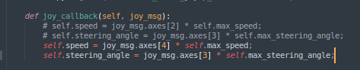
- Plug in your joystick
- Window 2: $ roslaunch nav joyop.launch # should now be able to drive around using the joystick

Start Tebplanner and use RVIZ to send navigation goals:

- Window 3: $ roslaunch nav nav_newteb.launch
- Window 4: $ rviz -d ~/catkin_ws_sim/src/nav/ack_new.rviz
- Change the Fixed Frame to odom
- 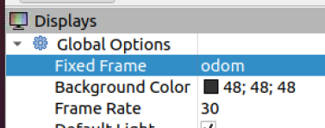
- Select Add; By Display type: Robot Model; OK
  - 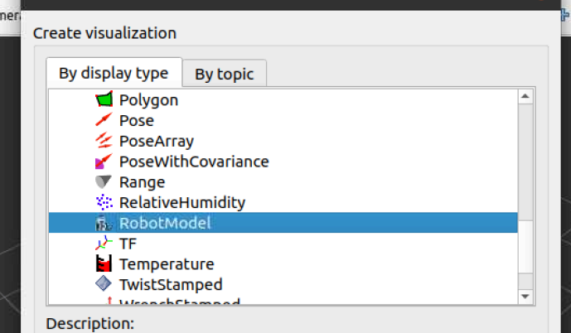
  - Select Add; By Topic:
    - /move_base/TebLocalPlannerROS/global_plan
    - 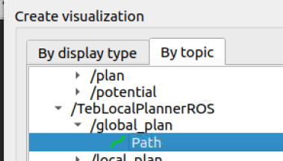
    - /move_base/TebLocalPlannerROS/local_plan
and save the configuration in local directory.
- 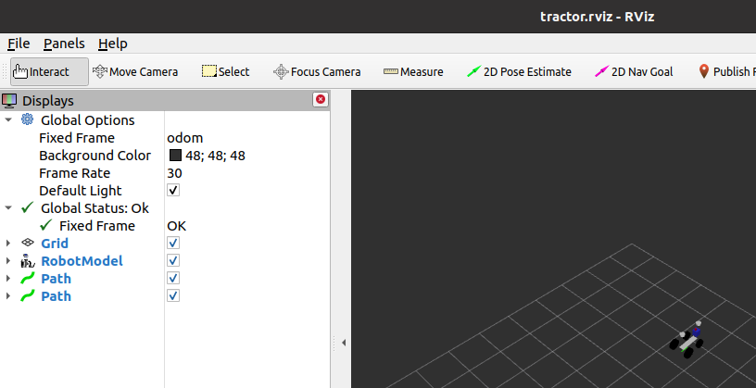
- Use 2D Nav Goal to send navigation commands

Change robot model
- Xacro file is in directory:
- /home/al/catkin_ws_sim_phase2/src/picar/src/ackermann_vehicle_description/urdf
- Open: robot.urdf.xacro

<?xml version="1.0"?>
<robot xmlns:xacro="http://www.ros.org/wiki/xacro" name="robot">
<!-- xacro:include filename="robot_core.xacro" / -->
<!-- <xacro:include filename="sammy_param.xacro" /> -->
<!-- <xacro:include filename="sammy_sensors.xacro" /> -->
<xacro:include filename="cub_cadet_param.xacro" />
<xacro:include filename="ack_new_macros.xacro" />
<xacro:include filename="sammy_sensors.xacro" />
</robot>

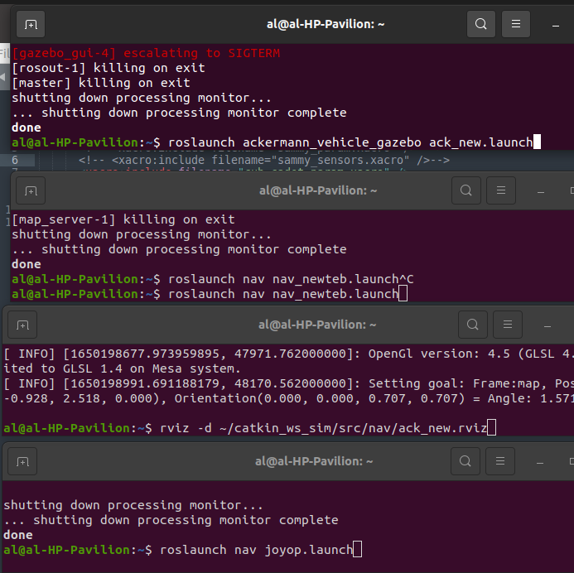
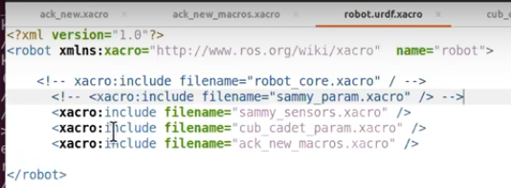

Older Notes are below this point………….

Start navigation using move_base with teb_local_planner:
$ sudo apt-get install ros-noetic-navigation
$ sudo apt-get install ros-noetic-teb-local-planner
$ roslaunch nav nav_newteb.launch

Change robot model

  - You can run a joystick with either of these commands:<BR>
  - roslaunch nav joy.launch<BR>
  - roslaunch nav joyop.launch<BR><BR>

  - Or to start navigation using move_base with teb_local_planner:<BR>
  - roslaunch nav nav_newteb.launch<BR>

  - To view the vehicle and send navigation goals:<BR>
  - rviz -d ~/catkin_ws_sim/src/nav/ack_new.rviz<BR>

This assumes you already have a catkin_ws directory in your home directory.

This is intends that you will install the catkin_ws_sim_phase2 along side the existing catkin_ws. See README.md to switch the "source" between catkin_ws and catkin_ws_sim_phase2.
source /opt/ros/noetic/setup.bash
# source ~/catkin_ws/devel/setup.bash
# source ~/catkin_ws_sim/devel/setup.bash
source ~/catkin_ws_sim_phase2/devel/setup.bash

View the OriginalInitialInstallNotes.txt that was originally posted to Slack. (that was for the first phase, catkin_ws_sim)

This is for the first URDF experiment; labeled catkin_ws_sim.
The second one is called catkin_ws_sim_phase2.
So everywhere below where it says catkin_ws_sim assume it should be catkin_ws_sim_phase2.
=========================================================================================
Then go here:
https://drive.google.com/drive/folders/1t2P2sfiranPe10fmUBUnnVvKNgrfybAV

And go into jeffs_ackermann_simulation you should see a catlin_ws_sim directory. If you click on that and do a download (under the 3 dots by the trash can in upper right hand corner) it will generate a ZIP file and down load to your downloads directory. You can unzip it there. Go into the resulting directory and copy the catkin_ws_sim directory to your home directory.(Along side of your existing catkin_ws.)

I assume your .bashrc has:
source ~/catkin_ws/devel/setup.bash
and replace it with:
source ~/catkin_ws_sim/devel/setup.bash

Restart all of your terminal windows.

The README.md file has a list of dependencies to load. (If you know what you are doing you could probably fix these with rosdep. But I just loaded them.) Load all of these before you do a catkin_make. (If you have already loaded these, you don't need to do this again.)

Open a window and go to the catkin_ws_sim directory and do:
catkin_make

If that works then I noticed the zipped file transfer deleted the execute permissions on the Python files. So you have to fix those.

catkin_ws_sim/src/my_odom_publisher/src/odom.py
catkin_ws_sim/src/nav/nodes/cmd_vel_to_ackermann_drive.py
catkin_ws_sim/src/nav/nodes/joyop.py
catkin_ws_sim/src/nav/nodes/mod_cmd_vel_to_ackermann.py
catkin_ws_sim/src/picar/src/picar/src/ackermann_vehicle_gazebo/scripts/ackermann_controller

If you get that far then you can execute the launch files listed in the README.md file. Or, if you don't want to waste a lot of time and just want to look at the files, you can look at them on Google drive. Or down load them to your computer and dig through them there.

There is no guarantee this is going to work...

# test1

<b>Test to see how this works</b>

To fix missing/bad keys
https://answers.ros.org/question/379190/apt-update-signatures-were-invalid-f42ed6fbab17c654/

<b>You may need these dependencies:</b>

sudo apt-get install ros-noetic-ackermann-msgs<br>
sudo apt-get install ros-noetic-gazebo-ros-pkgs ros-noetic-gazebo-ros-control<br>
sudo apt-get install ros-noetic-effort-controllers<br>
sudo apt-get install ros-noetic-geographic-msgs<br>
sudo apt install ros-noetic-joy<br>
sudo apt install ros-noetic-teleop-twist-joy<br>
sudo apt-get install ros-noetic-move-base-flex<br>
sudo apt-get install ros-noetic-teb-local-planner<br>
sudo apt install ros-noetic-tf2-tools<br>
sudo apt-get install ros-noetic-navigation<br>

<b>Notes:</b>

Since the workspace is named catkin_ws_sim_phase2 instead of catkin_ws you may need to update the source line in the .bashrc file.

To start the simulator:<BR>
roslaunch ackermann_vehicle_gazebo ack_new.launch<BR>

You can run a joystick with either of these commands:<BR>
roslaunch nav joy.launch<BR>
roslaunch nav joyop.launch<BR><BR>

Or to start navigation using move_base with teb_local_planner:<BR>
roslaunch nav nav_newteb.launch<BR>

To view the vehicle and send navigation goals:<BR>
rviz -d ~/catkin_ws_sim/src/nav/ack_new.rviz<BR>

- Download Jeff’s WS from Google
- 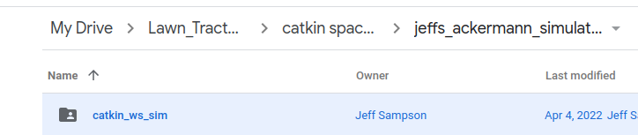
- Extract src folders
- 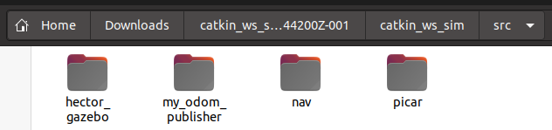
- Move folders to catkin_ws\src …
- 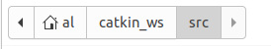
- 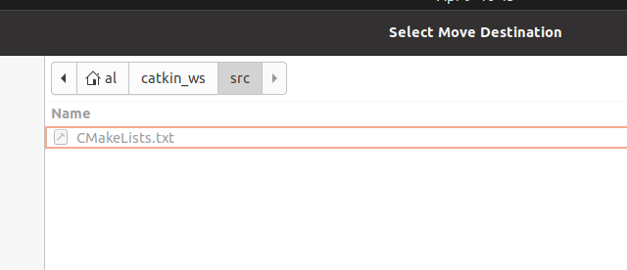

- $ sudo apt-get install ros-noetic-geographic-msgs
- $ sudo apt-get install ros-noetic-ackermann-msgs
- $ sudo apt-get install ros-noetic-effort-controllers
- $ cd /home/al/catkin_ws/src/my_odom_publisher/src
- $ chmod +x odom.py
- $ cd ~/catkin_ws
- $ catkin_make
- $ cd
- $ roslaunch ackermann_vehicle_gazebo ack_new.launch
- Close the process

Adjust to match your joystick and drive around
- Plug in your joystick
- $ sudo jstest /dev/input/js1 # to confirm your joystick is publishing on js1
- Determine which axes you want to control speed and steering and update values in joyop.py
- $ sudo jstest /dev/input/js1
- Use Sublime; Open joyop.py and adjust speed and angle axes reference to match your joystick
- $ sudo apt install ros-noetic-teleop-twist-joy
- $ cd /home/al/catkin_ws/src/nav/nodes
- $ chmod +x cmd_vel_to_ackermann_drive.py
- $ chmod +x joyop.py
- $ chmod +x mod_cmd_vel_to_ackermann.py
- $ cd
- $ cd ~/catkin_ws
- $ catkin_make
- $ cd
- Window 1: $ roslaunch ackermann_vehicle_gazebo ack_new.launch
- Window 2: $ roslaunch nav joyop.launch # should now be able to drive around using the joystick

Use RVIZ to send navigation goals:

- $ rviz -d ~/catkin_ws_sim/src/nav/ack_new.rviz
- Add:
  - Robot Model,
  - /move_base/TebLocalPlannerROS/global_plan
  - /move_base/TebLocalPlannerROS/local_plan
  - Change the Fixed Frame to odom
and save the configuration

Start navigation using move_base with teb_local_planner:
$ sudo apt-get install ros-noetic-navigation
$ sudo apt-get install ros-noetic-teb-local-planner
$ roslaunch nav nav_newteb.launch

Change robot model

Other references:
https://github-wiki-see.page/m/heechul/picar/wiki/ROS-PiCar-Setup

$ history
1 sudo apt install chrony
2 sudo systemctl enable chrony
3 sudo systemctl start chrony
4 sudo systemctl status chrony
5 sudo apt install curl
6 curl -s https://raw.githubusercontent.com/ros/rosdistro/master/ros.asc | sudo apt-key add -
7 sudo apt update
8 sudo apt upgrade
9 wget -qO - https://download.sublimetext.com/sublimehq-pub.gpg | sudo apt-key add -
10 sudo apt-get install apt-transport-https
11 echo "deb https://download.sublimetext.com/ apt/stable/" | sudo tee /etc/apt/sources.list.d/sublime-text.list
12 sudo apt-get update
13 sudo apt-get install sublime-text
14 sudo apt install git
15 git clone https://github.com/linorobot/rosme
16 cd rosme
17 ./install
19 sudo rosdep init
20 rosdep update
21 cd
23 source /opt/ros/noetic/setup.bash
24 mkdir -p ~/catkin_ws/src
25 cd ~/catkin_ws/
26 catkin_make
27 source devel/setup.bash
28 echo $ROS_PACKAGE_PATH
29 roscd
cd
30 nano ~/.bashrc
31 history
32 history > historyrosinstall20220409.txt

11/16/22 - exploring the setup
$ rosservice call /gazebo/get_world_properties "{}"
$ rosservice call /gazebo/get_model_properties ackermann_vehicle

$ roslaunch ackermann_vehicle_gazebo ack_new.launch

<launch>
…
<arg name="world_name" default="worlds/empty.world"/>
<arg name="cmd_timeout" default="0.5"/>
<!-- Vehicle pose -->
….
<include file="$(find ackermann_vehicle_description)/launch/ack_new.launch">
…
<include file="$(find gazebo_ros)/launch/empty_world.launch">
…
<arg name="world_name" value="$(find hector_gazebo_worlds)/worlds/sick_robot_day_2012_20m.world"/>
…
<node name="spawn_vehicle" pkg="gazebo_ros" type="spawn_model"
args="-urdf -param robot_description -model ackermann_vehicle
…
<node name="controller_spawner" pkg="controller_manager" type="spawner"
…
<node name="ackermann_controller" pkg="ackermann_vehicle_gazebo"
type="ackermann_controller">
…
<rosparam file="$(find ackermann_vehicle_gazebo)/config/em_3905_ackermann_ctrlr_params.yaml" command="load"/>
…
<include file="$(find my_odom_publisher)/launch/start_odom.launch"/>
</launch>

$ roslaunch nav joyop.launch # should now be able to drive around using the joystick

/home/tractor/catkin_ws/src/nav

<node name="joy" type="joy_node" pkg="joy">
<node name="joyop" type="joyop.py" pkg="nav" output='screen' args="$(arg max_speed)

$ roslaunch nav nav_newteb.launch

<launch>
..
<node name="map_server" pkg="map_server" type="map_server" args="$(find nav)/maps/farm.yaml"/>
…
<node pkg="tf2_ros" type="static_transform_publisher" name="map_to_odom" args="0 0 0 0 0 0 map odom" />
…
<node pkg="move_base" type="move_base" respawn="false" name="move_base" output="screen">
<rosparam file="$(find nav)/config_newteb/costmap_common_params.yaml" command="load" ns="global_costmap" />
<rosparam file="$(find nav)/config_newteb/costmap_common_params.yaml" command="load" ns="local_costmap" />
…

<!-- Set "cmd_angle_instead_rotvel" to "True" and use mod_cmd_vel_to_ackermann.launch -->
<include file="$(find nav)/launch/mod_cmd_vel_to_ackermann.launch" />
…

$ rviz -d ~/catkin_ws_sim/src/nav/ack_new.rviz

So lets take steering as an example. At the moment I move the steering joystick and the wheels turn left and right in Gazebo. In the physical world the wheels have not moved. Gazebo is getting the state of the wheels from somewhere other than the actual steering sensor. Where is that?

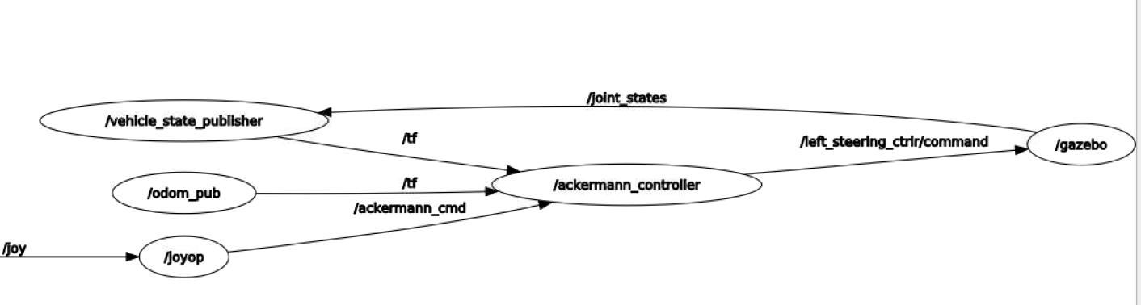

$ rosrun rqt_graph rqt_graph

http://wiki.ros.org/ackermann_steering_controller
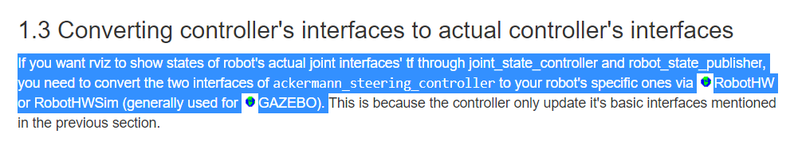

Starting from the beginning
https://github.com/nickcharron/waypoint_nav
- fuse odometry data with IMU and GPS data

